Study 2

Survey Flow

Block: Default Question Block (4 Questions)

Standard: Instructions (10 Questions)

BlockRandomizer: 1 - Evenly Present Elements

Branch: New Branch

If

If Hello! The following is a consent form for participating in our study. Please read carefully befo... Is Displayed

EmbeddedData

Group = A

Standard: Group A (3 Questions)

Branch: New Branch

If

If Hello! The following is a consent form for participating in our study. Please read carefully befo... Is Displayed

EmbeddedData

Group = B

Standard: Group B (3 Questions)

Standard: Graph Literacy Scale (6 Questions)

Standard: Debriefing questions (2 Questions)

Standard: Demographics (7 Questions)

WebService: GET - http://reporting.qualtrics.com/projects/randomNumGen.php - Fire and Forget

Standard: Debrief and goodbye (4 Questions)

|  |  |
| --- | --- |
| Page Break |  |

Start of Block: Default Question Block

* **Hello!**The following is a consent form for participating in our study. Please read carefully before continuing.

consent **I have read this consent form, and I consent to my participation in the research described above.**

* I consent

workerID Enter your workerID below:

________________________________________________________________

End of Block: Default Question Block

Start of Block: Instructions

*Welcome **Welcome!**   
    
We are interested in how people interpret graphs about a range of issues. Please read the following instructions carefully.

|  |  |
| --- | --- |
| Page Break |  |

*Warning **Instructions (Please read!)**  In this task, you will see a series of graphs. For each graph, you will be asked about the information presented.   
    
Some the graphs were created to be **misleading.**    
    
For example, you might see a graph where the y-axis does not start at 0, as in the graph on the left. We call this technique axis truncation. As you can see, this gives the impression that there is a larger difference in interest rates between 2008 and 2012 than might be warranted.    
    
Don't spend too long on any question. It is okay if some of the topics are unfamiliar to you. Look at the graphs as you would if you encountered them in a newspaper or magazine article.

|  |  |
| --- | --- |
| Page Break |  |

|  |
| --- |
|  |

Check   
 **Quick Check** Click the graph below that was designed to be misleading.

* Graph #1
* Graph #2

|  |  |
| --- | --- |
| Page Break |  |

Display This Question:

If Quick Check Click the graph below that was designed to be misleading.   = Graph #2

Correct **CORRECT!**   
Nice job! Graph #2 was designed to be misleading, because the y-axis does not start at 0.   
    
  Graph #1   
  
   
     
    
*Graph #2*   
​

|  |  |
| --- | --- |
| Page Break |  |

Display This Question:

If Quick Check Click the graph below that was designed to be misleading.   = Graph #1

Incorrect **X INCORRECT.**  
 Actually, the second graph is more misleading because the vertical axis of **graph #2 does not start at 0**.   
    
graph #1  
   
    
graph #2

|  |  |
| --- | --- |
| Page Break |  |

*Sample Trial **Sample Trial**  
  
This an example of what you'll see in our study. Make a choice based on the graph.

*Sample Trail

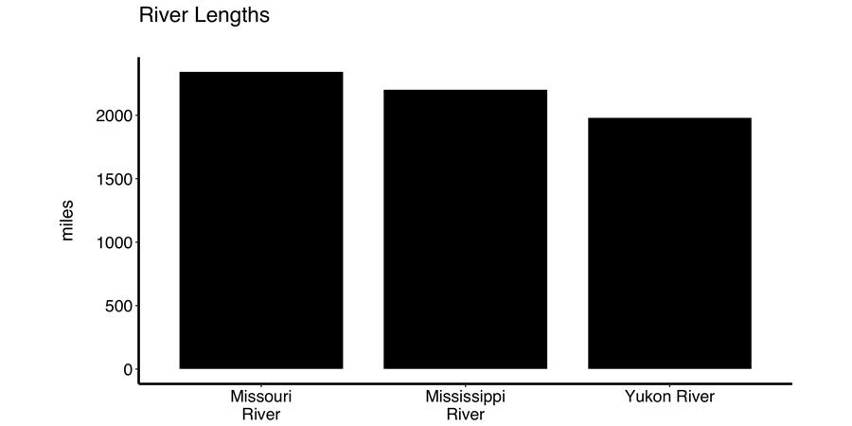

*Sample_rating Compare the lengths of the Yukon River and the Missouri River. How different are they?

* 1 not at all different
* 2
* 3
* 4 moderately different
* 5
* 6
* 7 extremely different

|  |  |
| --- | --- |
| Page Break |  |

|  |
| --- |
|  |

*Good Job **Great job!** Now you will complete the remainder of the study.  
  
  
We ask that you stay within the survey window for the duration of the study for the integrity of our research.

End of Block: Instructions

Start of Block: Group A

A Look at the following graph:

rating_A Compare the ${lm://Field/2} **${lm://Field/3}** and **${lm://Field/4}**. How different are they?

* ${*Sample_rating/ChoiceDescription/1}
* ${*Sample_rating/ChoiceDescription/2}
* ${*Sample_rating/ChoiceDescription/3}
* ${*Sample_rating/ChoiceDescription/4}
* ${*Sample_rating/ChoiceDescription/5}
* ${*Sample_rating/ChoiceDescription/6}
* ${*Sample_rating/ChoiceDescription/7}

timing_A Timing

First Click

Last Click

Page Submit

Click Count

End of Block: Group A

Start of Block: Group B

B Look at the following graph:

rating_B Compare the ${lm://Field/2} **${lm://Field/3}** and **${lm://Field/4}**. How different are they?

* ${*Sample_rating/ChoiceDescription/1}
* ${*Sample_rating/ChoiceDescription/2}
* ${*Sample_rating/ChoiceDescription/3}
* ${*Sample_rating/ChoiceDescription/4}
* ${*Sample_rating/ChoiceDescription/5}
* ${*Sample_rating/ChoiceDescription/6}
* ${*Sample_rating/ChoiceDescription/7}

timing_B Timing

First Click

Last Click

Page Submit

Click Count

End of Block: Group B

Start of Block: Graph Literacy Scale

* **Nice job!**   
    
The study is almost complete. Now, you will answer a few questions about your experience with graphs.

|  |  |
| --- | --- |
| Page Break |  |

Instructions **Instructions**   
    
Read and answer the questions below. If you are unfamiliar with a particular graph, select **1** = not at all good.

Graphicacy_1   
  
Read and answer the questions below.

|  |  |  |  |  |  |  |
| --- | --- | --- | --- | --- | --- | --- |
|  | 1 | 2 | 3 | 4 | 5 | 6 |
| How good are you at working with bar charts? |  |  |  |  |  |  |
| How good are you at working with line plots? |  |  |  |  |  |  |
| How good are you at working with pies? |  |  |  |  |  |  |
| How good are you at inferring the size of a bar in a bar chart? |  |  |  |  |  |  |
| How good are you at determining the difference between 2 bars in a bar chart? |  |  |  |  |  |  |
| How good are you at projecting a future trend from a line chart? |  |  |  |  |  |  |

|  |  |
| --- | --- |
| Page Break |  |

Graphicacy_7 Read and answer the questions below.

|  |  |  |  |  |  |  |
| --- | --- | --- | --- | --- | --- | --- |
|  | 1 | 2 | 3 | 4 | 5 | 6 |
| Are graphs easier to understand than numbers? |  |  |  |  |  |  |

|  |  |
| --- | --- |
| Page Break |  |

Graphicacy_8 Read and answer the questions below.

|  |  |  |  |  |  |  |
| --- | --- | --- | --- | --- | --- | --- |
|  | 1 | 2 | 3 | 4 | 5 | 6 |
| How often do you find graphical information to be useful? |  |  |  |  |  |  |

|  |  |
| --- | --- |
| Page Break |  |

Graphicacy_9 Read and answer the questions below.

|  |  |  |  |  |  |  |
| --- | --- | --- | --- | --- | --- | --- |
|  | 1 | 2 | 3 | 4 | 5 | 6 |
| To what extent do you believe in the saying ‘‘a picture is worth one thousand words"? |  |  |  |  |  |  |
| When reading books or newspapers, how helpful do you find graphs that are part of a story? |  |  |  |  |  |  |

End of Block: Graph Literacy Scale

Start of Block: Debriefing questions

* Finally, you will answer a few questions about the survey experience and yourself.  
  
  
Your responses to these questions will help us interpret our data set. Remember that all information you provide is confidential and your name will not appear on this document. Answering these question is voluntary and you can choose to skip any or all of them.

|  |  |
| --- | --- |
| Page Break |  |

|  |
| --- |
|  |

DB_approach Which of the following best describes your approach to answering questions about the graphs? You may select one, more than one, or none at all.  
  
  
**Note**: There is no "wrong answer," and  you may not have used any of these approaches.

* Comparing the values of the bars based on vertical axis (y-axis)
* Comparing the areas of the bars visually
* Using hands, fingers, or other physical objects to measure the heights of bars
* Judging intuitively how different the bars look i.e. how different they "feel"
* Using what I already knew about the topics to answer some of the questions (e.g. I already knew about the weights of brown bears versus cows)
* Other: ________________________________________________

End of Block: Debriefing questions

Start of Block: Demographics

* **Questions about you**

dem_browser Browser Meta Info

Browser

Version

Operating System

Screen Resolution

Flash Version

Java Support

User Agent

|  |
| --- |
|  |

dem_age Current age:

________________________________________________________________

dem_gender I identify my gender as:

________________________________________________________________

|  |  |
| --- | --- |
|  |  |

dem_ed Please indicate the highest level of education you have attained:

* Some high school
* Graduated high school (or G.E.D.)
* Some college
* Currently in college (please indicate year) ________________________________________________
* Associate's degree
* Bachelor's degree
* Completion of some graduate school courses
* Graduate degree (indicate degree below) ________________________________________________

dem_language First Language:

* English
* Other (please write): ________________________________________________

dem_language_string (optional) If other than English, number of years you have spoken English:

________________________________________________________________

End of Block: Demographics

Start of Block: Debrief and goodbye

|  |
| --- |
|  |

*   
**Experimental Debrief**   
   
 What was happening during the experiment? During this study, you saw different types of graphs. Some of the graphs represented information in a way that was designed to be misleading. We used tactics that are seen in the media regularly. For example, one technique is to change the vertical axis (y-axis) to make small difference seem larger:     
     In this study, some of the graphs were manipulated in this way.  
  **What are trying to learn in this research?** We are interested in how people are persuaded and how people change their beliefs. We would like to go how graphs play a role in these processes, how misleading these deceptive graphs really are, and whether they are ways to combat deceptive graphs.   **Why is this research important?** You may have heard the terms “post-truth” or “fake news” being used more frequently in the media. Knowing more about what contributes to persuasion and belief change is important to understanding how false beliefs and misinformation propagate and stick around. It is also relevant to efforts to change people’s minds about issues that have concrete consequences, such as rates of vaccination in children and environmental issues.   
 **What are our predictions?** We predict that evidence involving visual representations, such a graphs, will be more persuasive than text or statistical evidence alone.   
  **What if I have questions later?** If you have questions, you can contact Brenda Yang at 919-660-5797 or brenda.yang@duke.edu.

|  |  |
| --- | --- |
| Page Break |  |

DB_misleading_percen Give an estimate the percentage of graphs that were misleading, as described in the experimental debrief.   
   
(Give your best guess -- we expect that it is difficult to know this exactly.)

|  |  |  |  |  |  |  |  |  |  |  |  |
| --- | --- | --- | --- | --- | --- | --- | --- | --- | --- | --- | --- |
|  | 0 | 10 | 20 | 30 | 40 | 50 | 60 | 70 | 80 | 90 | 100 |

|  |  |
| --- | --- |
| % of misleading graphs you saw |  |

|  |  |
| --- | --- |
| Page Break |  |

DB_strategy   
We are interested in how people might be approaching graphs that are misleading differently or not differently than accurate graphs.  
  
  
How would you describe your approach to graphs that were misleading?

________________________________________________________________

________________________________________________________________

________________________________________________________________

________________________________________________________________

________________________________________________________________

|  |  |
| --- | --- |
| Page Break |  |

|  |
| --- |
|  |

*   
**Great. Thank you for participating in our study!**  
   
Please put the following unique code into your MTurk survey:  
  
**H${e://Field/mTurkCode}**  
  
If you have any comments or thoughts on your experience, we welcome them in the "Comments" section on the MTurk form. If you are curious about what we are studying in this experiment, please contact brenda.yang@duke.edu. Have a nice day!

End of Block: Debrief and goodbye